IEEE PAPER ON
SMART IRRIGATION SYSTEM

abstract:
Precision Farming or Precision Agriculture is generally defined as information and technology based farm management system to identify, analyse and manage spatial and temporal variability within fields for optimum productivity and profitability, sustainability and protection of the land resource by minimizing the production costs. Increasing environmental consciousness of the general public is necessitating us to modify agricultural management practices for sustainable conservation of natural resources such as water, air and soil quality, while staying economically profitable

Introduction:
- SMART Irrigation is Sustainably Managed, Accountable, Responsible and Trusted-Irrigation.
- By precisely measuring variations within a field and adapting the strategy accordingly, farmers can greatly increase the effectiveness of pesticides and fertilizers, and use them more selectively.
- Similarly, using Smart Farming techniques, farmers can better monitor the needs of individual animals and adjust their nutrition correspondingly, thereby preventing disease and enhancing herd health

SOIL MOISTURE CONTENT USING
ESP8266:.

The Smart irrigation System has wide scope to automate the complete irrigation system. Here we are building a IoT based Irrigation System using ESP8266 NodeMCU Module and DHT11 Sensor.
It will not only automatically irrigate the water based on the moisture level in the soil but also send the Data Server to keep track of the land condition. The System will consist a water pump which will be used to sprinkle water on the land depending upon the land environmental condition such as Moisture. In this project two LEDs are used as an indicator.
Increasing environmental consciousness of the general public is necessitating us to modify agricultural management practices for sustainable conservation of natural resources such as water, air and soil quality, while staying economically profitable

Smart Farming techniques, farmers can better monitor the needs of individual animals and adjust their nutrition correspondingly, thereby preventing disease and enhancing herd health

Components Required:
- NodeMCU ESP8266
- 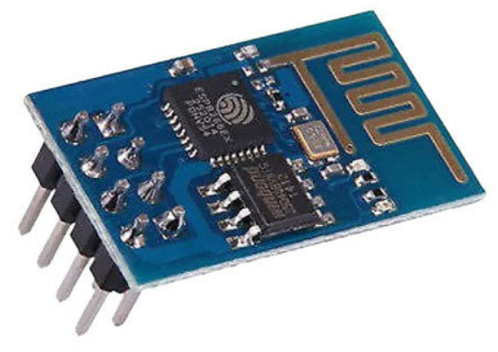
- Soil Moisture Sensor Module
- 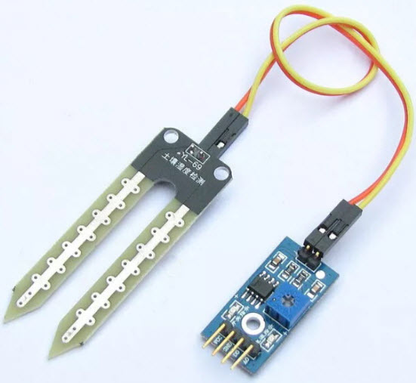
- LED
- 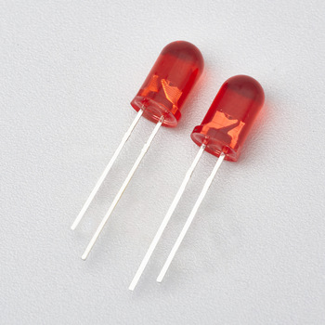
- Bread Board
- 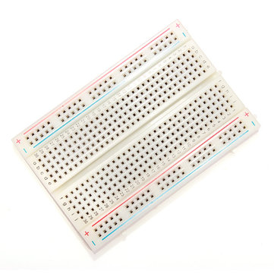
Connecting Wires
- 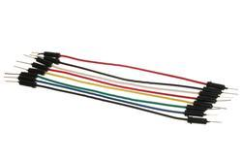

Programming ESP8266 NodeMCU for Automatic Irrigation System:
For programming the ESP8266 NodeMCU module, only the DHT11 sensor library is used as external library. The moisture sensor gives analog output which can be read through the ESP8266 NodeMCU analog pin A0. Since the NodeMCU cannot give output voltage greater than 3.3V from its GPIO so we are using a relay module to drive the 5V motor pump. Also the Moisture sensor and DHT11 sensor is powered from external 5V power supply.
The next Step is to write the Wi-Fi credentials such as SSID and Password. Define the DHT Sensor Pin where the DHT is connected and Choose the DHT type.

The moisture sensor output is connected to Pin A0 of ESP8266 NodeMCU. And the motor pin is connected to D0 of NodeMCU. Define the current time of starting the program and save it in a variable to compare it with the elapsed time. Read temperature and humidity data and save them into variables. If DHT is connected and the ESP8266 NodeMCU is able to read the readings then proceed to next step or return from here to check again.
Read the moisture reading from sensor and print the reading.

FLOW CHART:
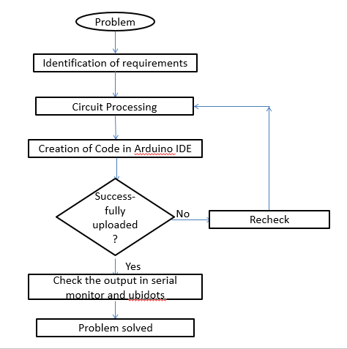

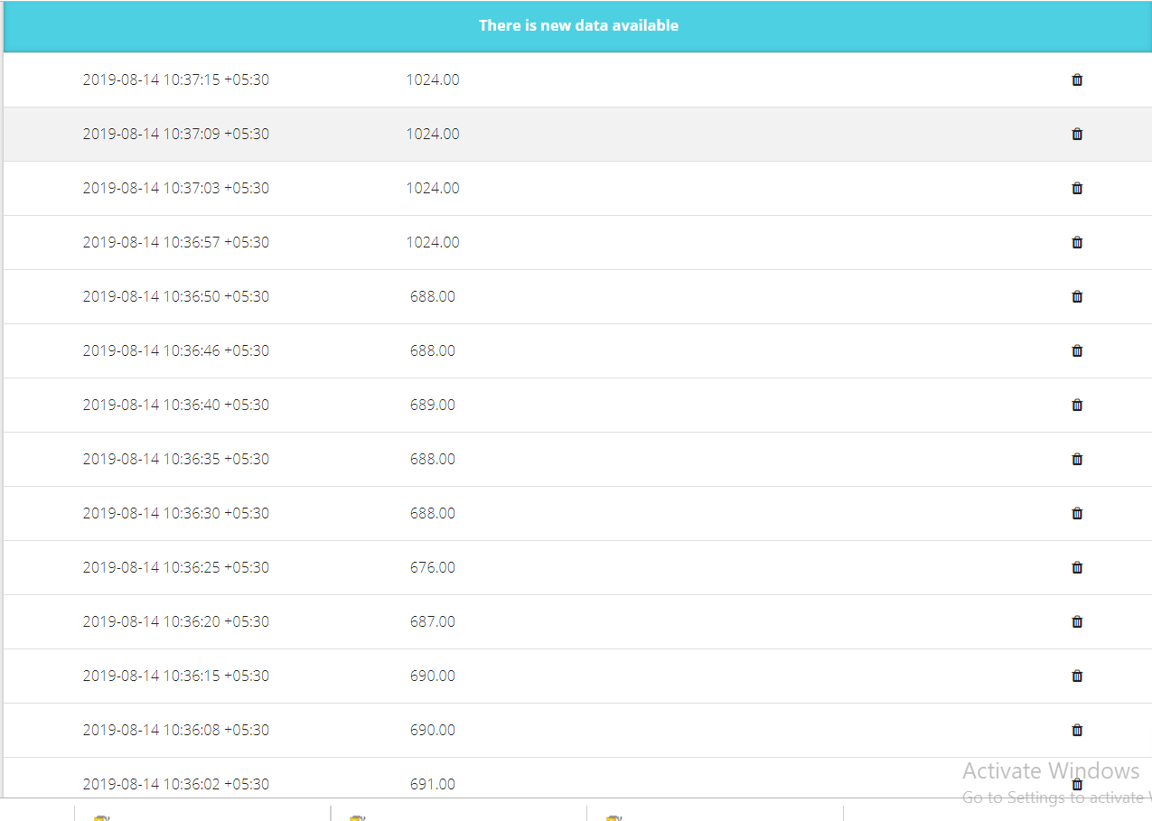

Process:
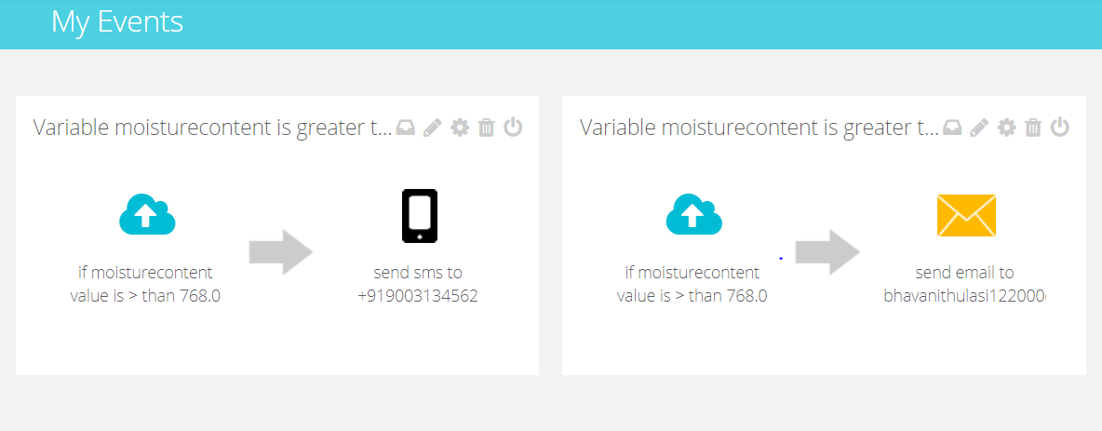

Result:
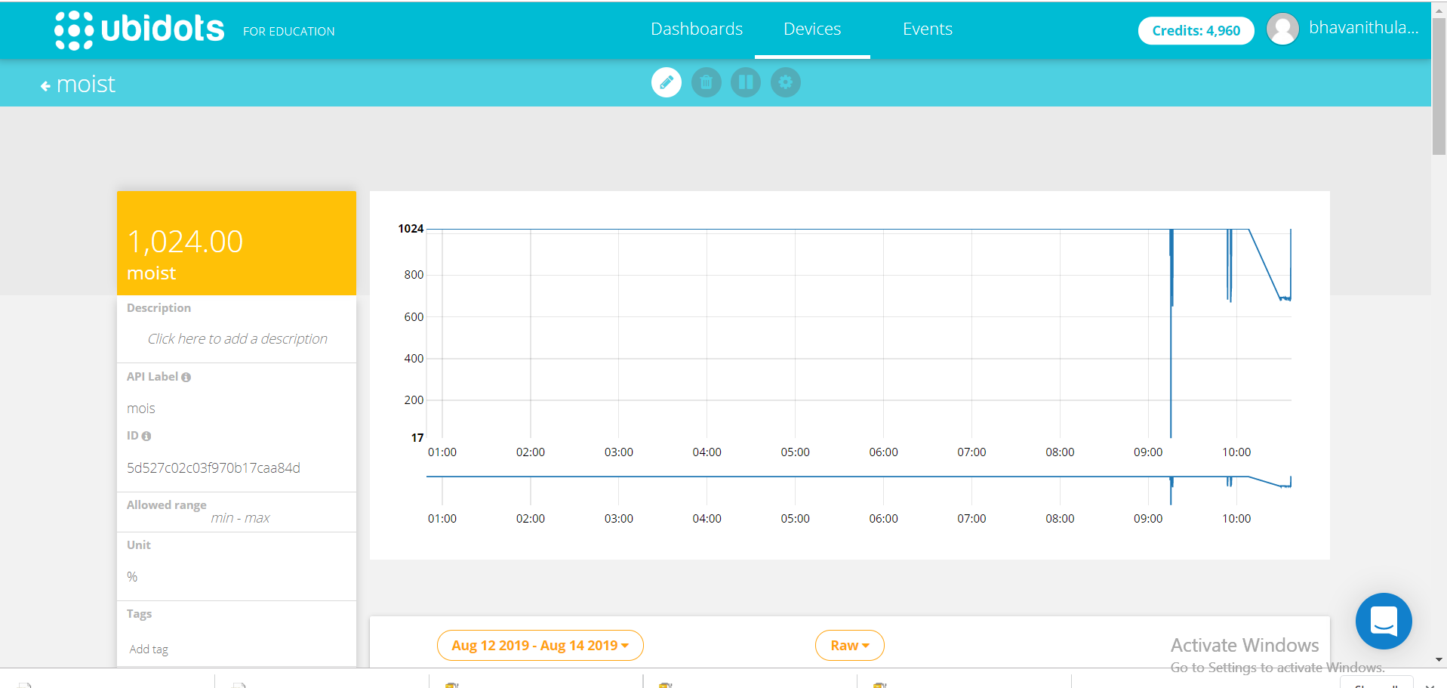
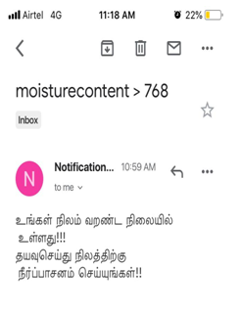

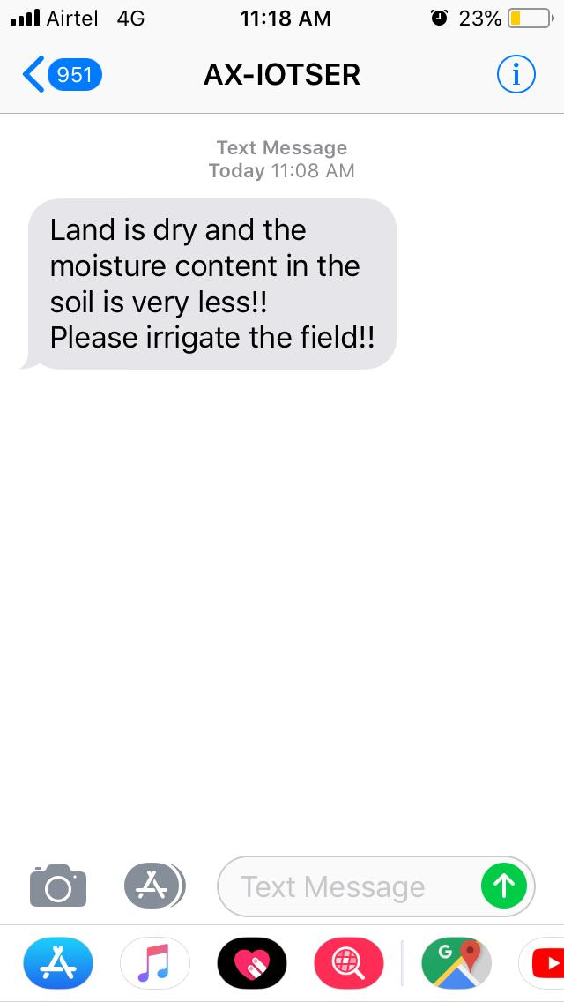

REFERENCES:
https://circuitdigest.com/microcontroller-projects/iot-based-smart-irrigation-system-using-esp8266-and-soil-moisture-sensor

https://app.ubidots.com/ubi/datasources/#/detail/5d5277b7c03f9707c6a96bf1

https://www.precisionag.com/digital-farming/what-is-digital-farming-really/

https://www.cropscience.bayer.com/en/stories/2014/digital-farming-bit-by-bit

https://www.netafimindia.com/digital-farming/

